CEWT – CRT Visual Pack

1. Exergy Sankey Diagram
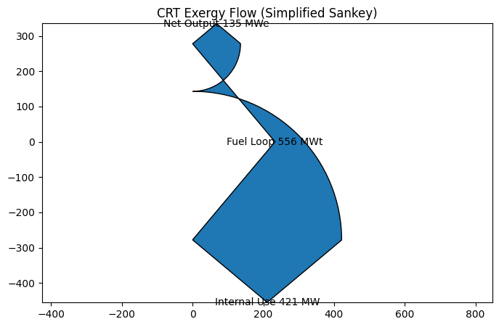

2. Dark Theme Infographic
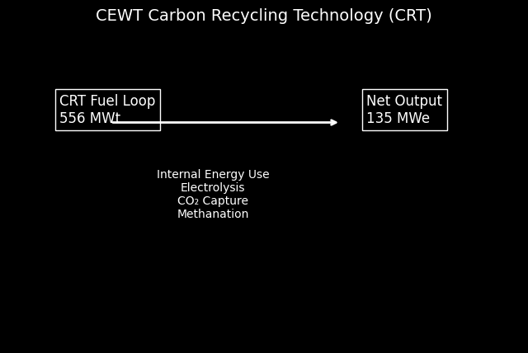

3. System Architecture Diagram
